Training Manual for getting started with PSOC™ Edge E84 MCU applications using Modus Toolbox™ software

About this document
Scope and purpose
This document is a training manual for the PSOC™ Edge E84 MCU. This Manual helps in getting started with PSOC™ Edge E84 MCU applications using Modus Toolbox™ software

Table of contents
Contents
About this document 1
Table of contents 1
1 Introduction 2
2 Required development tools 2
3 Prerequisites 2
4 Code Example 1: Hello world + Blinky 3
4.1 Objective 3
4.2 Description 3
4.3 Flowchart 3
4.4 Hardware Block Diagram and Setup 5
4.5 Project Creation 5
4.6 Conclusion 25
5 Code Example 2: IPC queues using HAL 26
5.1 Objective 26
5.2 Description 26
5.3 Flowchart 27
5.4 Hardware Block Diagram 28
5.5 Hardware Setup 28
5.6 Project Creation 29
5.7 Conclusion 48
6 References 49

Introduction
This manual provides specific instructions to create, configure , build and run several application code examples on the PSOC™ Edge E84.

Required development tools
- ModusToolbox™ software v3.6 or later (tested with v3.6)
  - ModusToolbox™ Programming Tools v1.6.0
- Extended Boot v1.1.0.1333.
- Board support package (BSP) minimum required version for:
  - KIT_PSOCE84_EVK: v0.8.0
- PSOC™ Edge E84 Evaluation Kit (KIT_PSE84_EVAL Rev G)
  - Ensure BOOT SW (SW6) should be in 'High'/ON position.
    - Note: For KIT_PSE84_EVAL rev. G, BOOT SW pin is BOOT.1 (P17.6)
  - Ensure J20 and J21 should be in Tristate/Not-Connected (NC) position.
- Tera Term or PuTTY

Prerequisites
- Introduction to PSOC™ Edge E84 (E1) video training session
Install the software listed below
- ModusToolbox™ software v3.6
- Install a terminal emulator if you do not have one. Instructions in this document use Tera Term..

- Code Example 1: Hello world + Blinky

  - Objective
This code example will teach you to create a simple UART communication by printing the “Hello World” message on a terminal and blinking an LED using a timer resource in PSOC™ Edge E84. . The code example uses the HAL (Hardware Abstraction Layer) library.

Description
This code example demonstrates the following algorithm flow:

Figure 1 Hello World + Blinky Algorithm Flow

Flowchart
Below flow chart explains the flow of CM33 non-secure project

Figure 2 Example figure

Below flow chart explains the flow of CM55 project

Figure 3 Example figure

Hardware Block Diagram and Setup
Below is the Hardware block diagram for Hello world + Blinky example as per the schematic
UART pins:
- P6_5 (UART_RX)
- P6_7 (UART_TX)
GPIO LED Pin
- P16_7 (USER_LED)

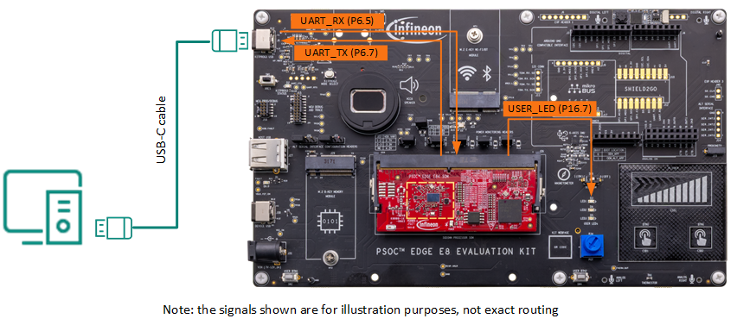
Figure 4 Hardware Diagram for UART and LED Routing on PSOC Edge E84 EVK

  - Project Creation
- Before creating the first project we need to create our workspace in Modus™ Toolbox. Open Modus™ Toolbox from the Windows Start menu.
Note: if you have not installed Modus tool box, Refer Required development tools section

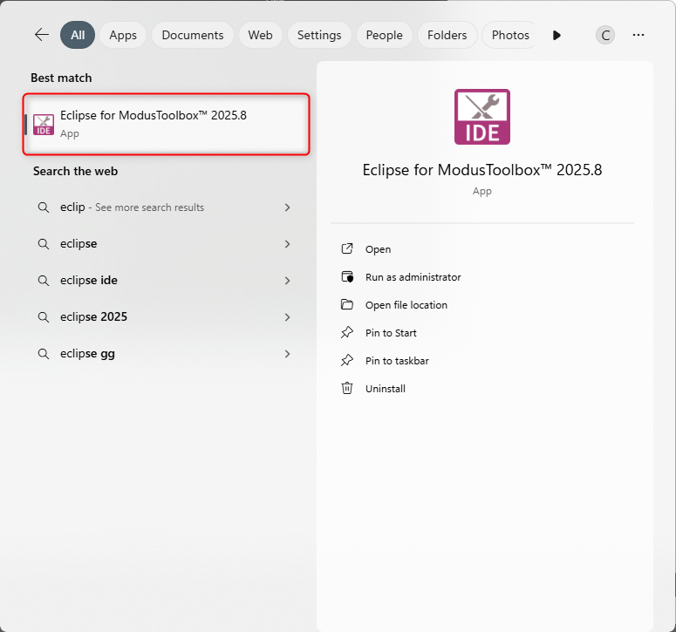
Figure 4 Example figure
- Next, you must choose a workspace directory for your project. After selecting a suitable directory, click the Launch button.

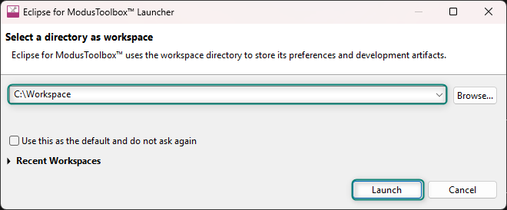
Figure 5 Example figure
- Hitting Launch will open a new Modus™ Toolbox workspace as shown below.

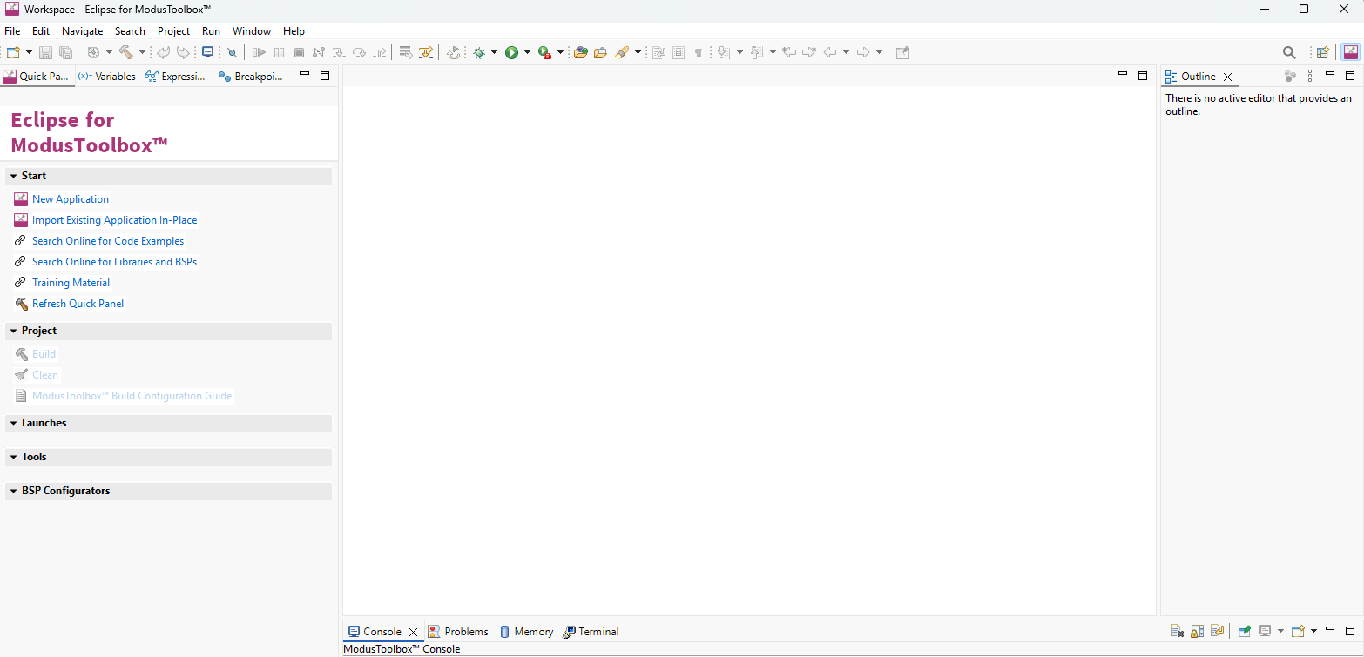
Figure 6 Example figure
- Now select New Application from the Quick Panel. Alternatively, go to File> New> Modus Toolbox™ Application

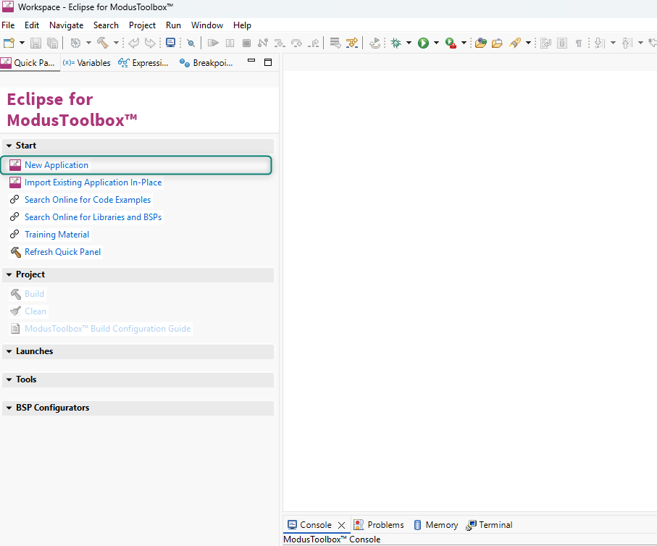
Figure 7 Example figure
- Clicking New Application will open the Project Creator Tool and prompt you to choose a BSP (Board Support Package).

BSPs are aligned with our development/evaluation kits; they provide files for basic device functionality. A BSP typically has a design.modus file that configures clocks and other board-specific capabilities. That file is used by the ModusToolbox™ configurators. A BSP also includes the required device support code for the device on the board. You can modify the configuration to suit your application.

- Once Projector creator launches, Select the KIT_PSE84_EVAL_EPC2 BSP under the PSOC™ Edge BSPs (or Detected Devices if your EVK is already connected). Then click Next.

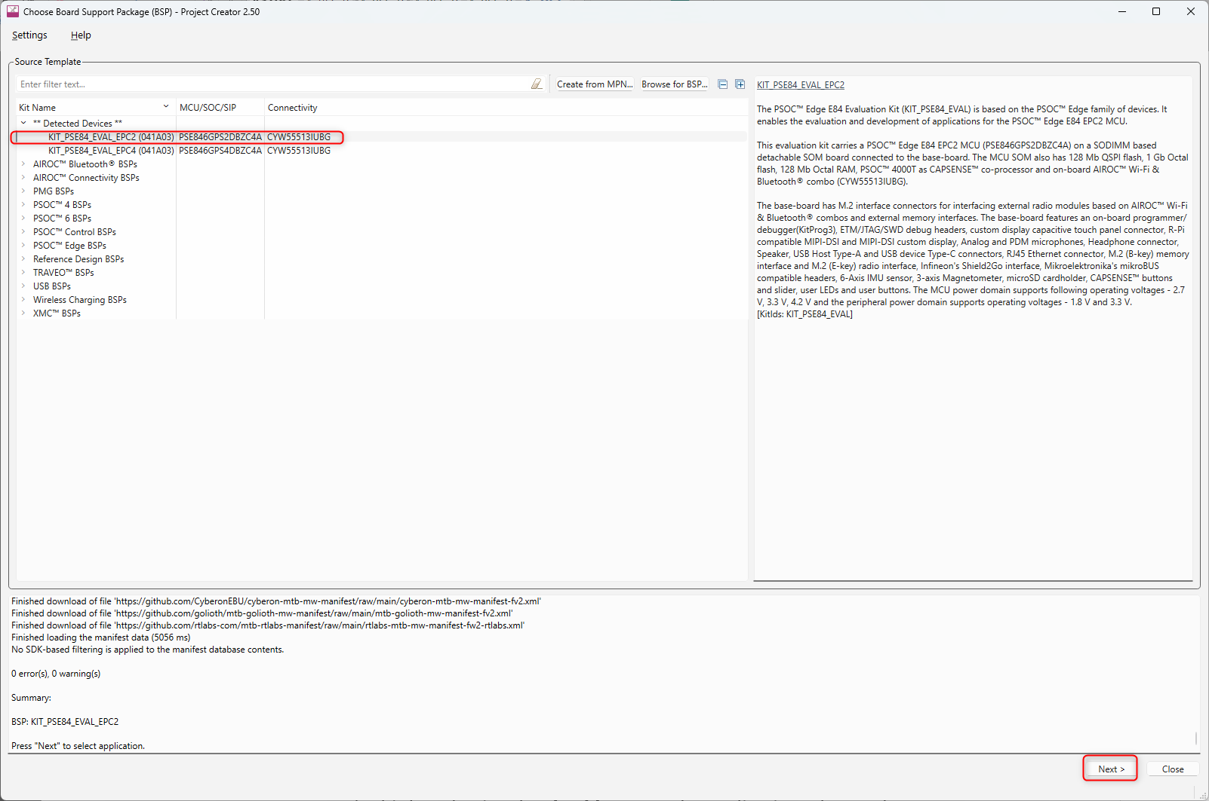
Figure 8 Example figure
- Clicking Next will take you to the next menu of the Project Creator which will ask you to select an Application. Select the PSOC Edge Empty Application under the Getting Started section. You can do this by selecting the checkbox near the application. Change the name to “PSOC_Edge_Hello_World” as we will be developing a hello world application and click on Create

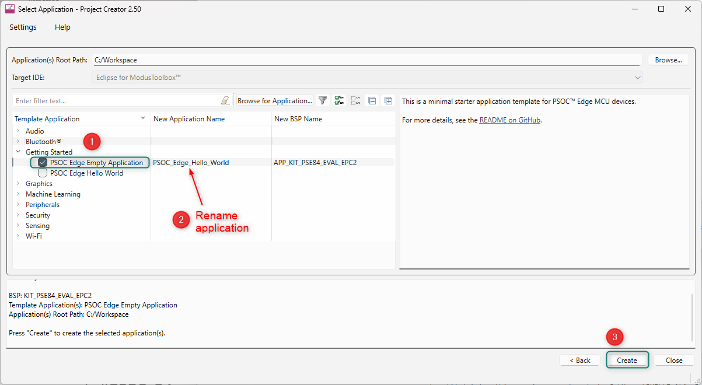
Figure 9 Example figure
- When you click Create, a new project is created, and you will be able to see all the files in the Project Explorer window.

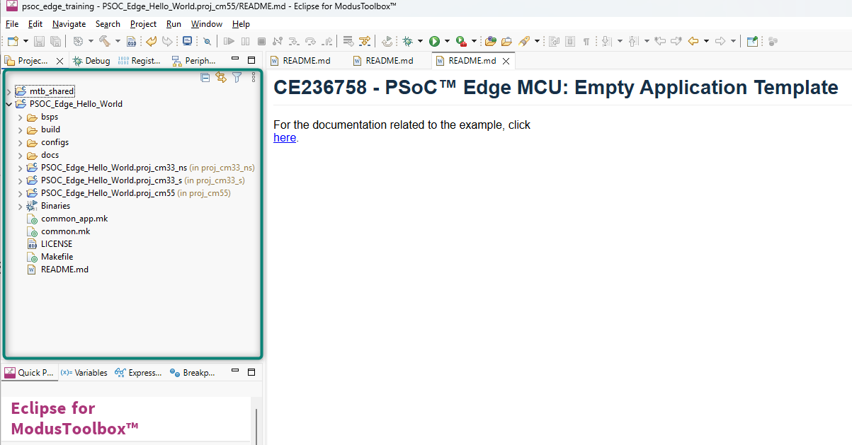
Figure 10 Example figure
- Expaning the main project folder, you can see that there are multiple sub-folders within it.

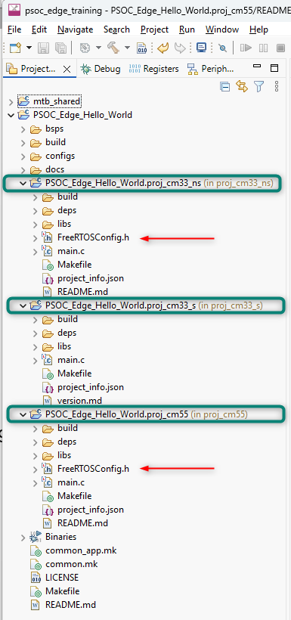
Figure 11 Example figure
Exploring the folders, you will see the FreeRTOS libraries have been imported into the project. But, since we are making a basic hello world blinky project, the FreeRTOS library is not needed. We will remove it using the Library Manager tool.
The Library Manager tool can be found in the Quick Panel tab directly below the Project Explorer in the Tools section. In addition, retargetIO will be needed for our project for using the UART functionalities. This will be added using the Library Manager as well.

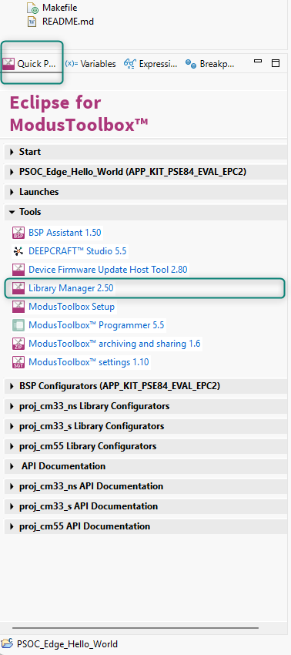
Figure 12 Example figure
- Select the PSOC_Edge_Hello_World project in the mtb project explorer and Open the Library Manager from Quick Panel. Find the freertos libraries under the proj_cm33_ns and proj_cm55 project libraries. Click the ‘X’ mark to remove the freertos library in each project’s libraries.

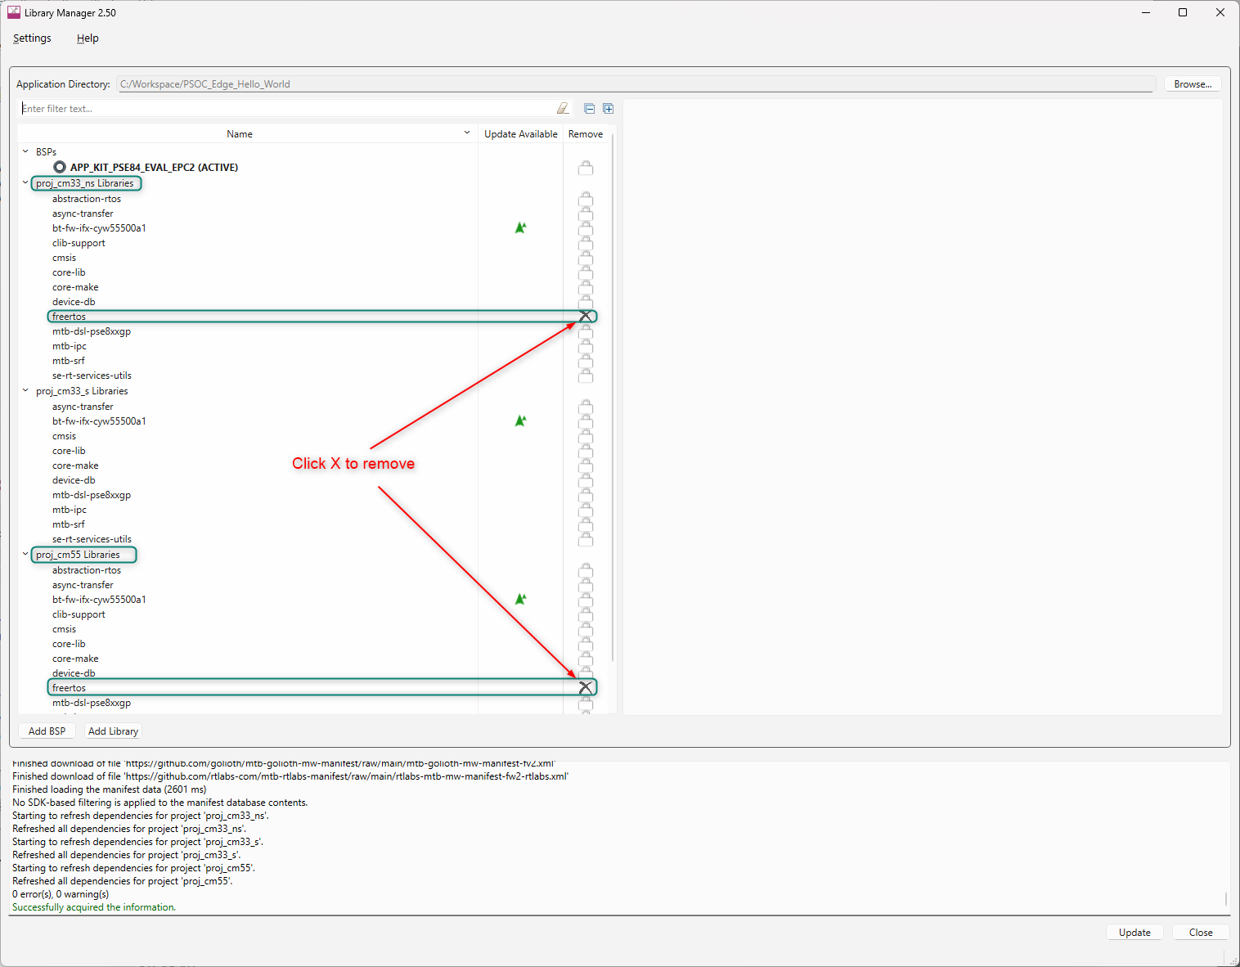
Figure 13 Example figure

Now, click the Add Library option. A menu will open. Search for retarget-io. It can be found under the Peripheral section. Select the retarget-io option for proj_cm33_ns and click OK.

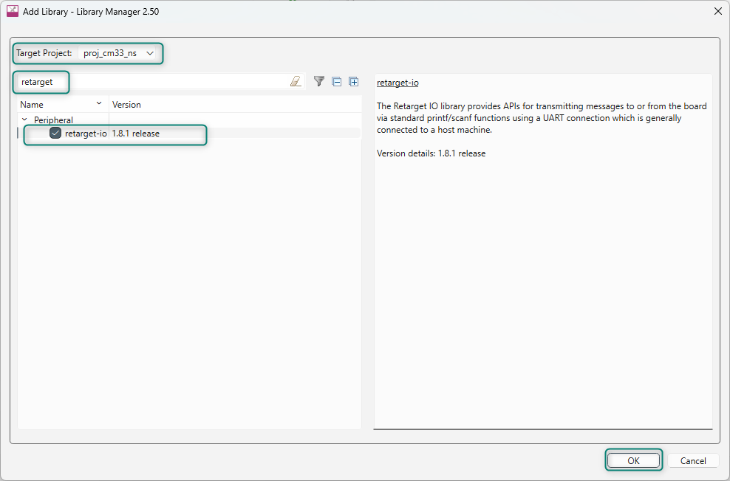
Figure 14 Example figure

Now, click Update on the Library Manager.

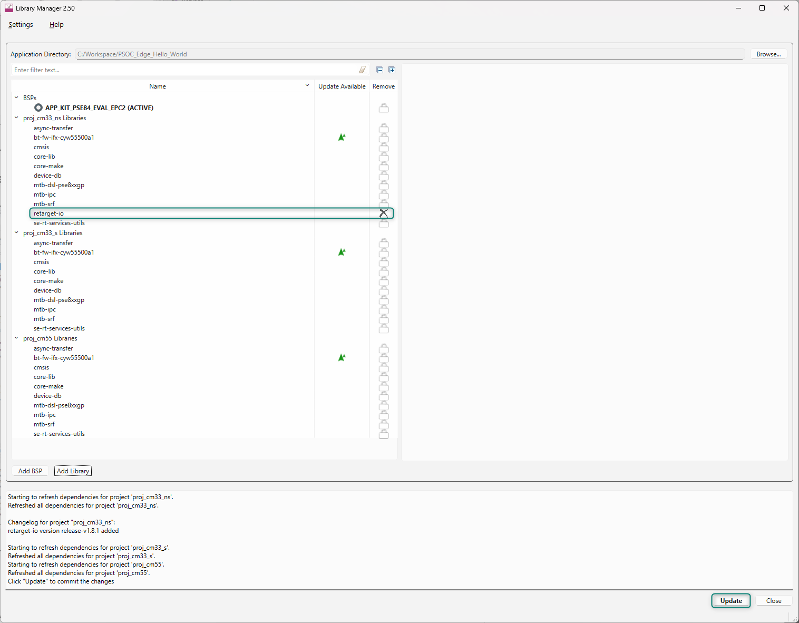
Figure 15 Example figure
Library Manager will update all the changes made to the hello world project. Close the Library Manager after the udpates have completed.

- Now let’s look how to configure or rename the pins using the Device Configurator.
Open the Device Configurator tool that can be found in the quick panel area under the BSP Configurators section.

The Device Configurator can be used to set up the system functions such as pins, interrupts, clocks, and DMA, as well as the basic peripherals, including UART, Timer, etc.

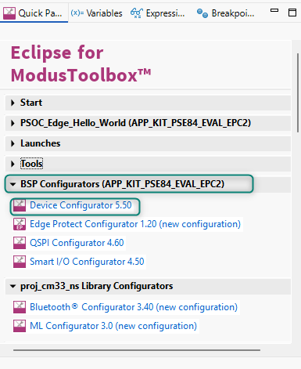
Figure 16 Example figure
- After opening the Device Configurator go to the Pins section.

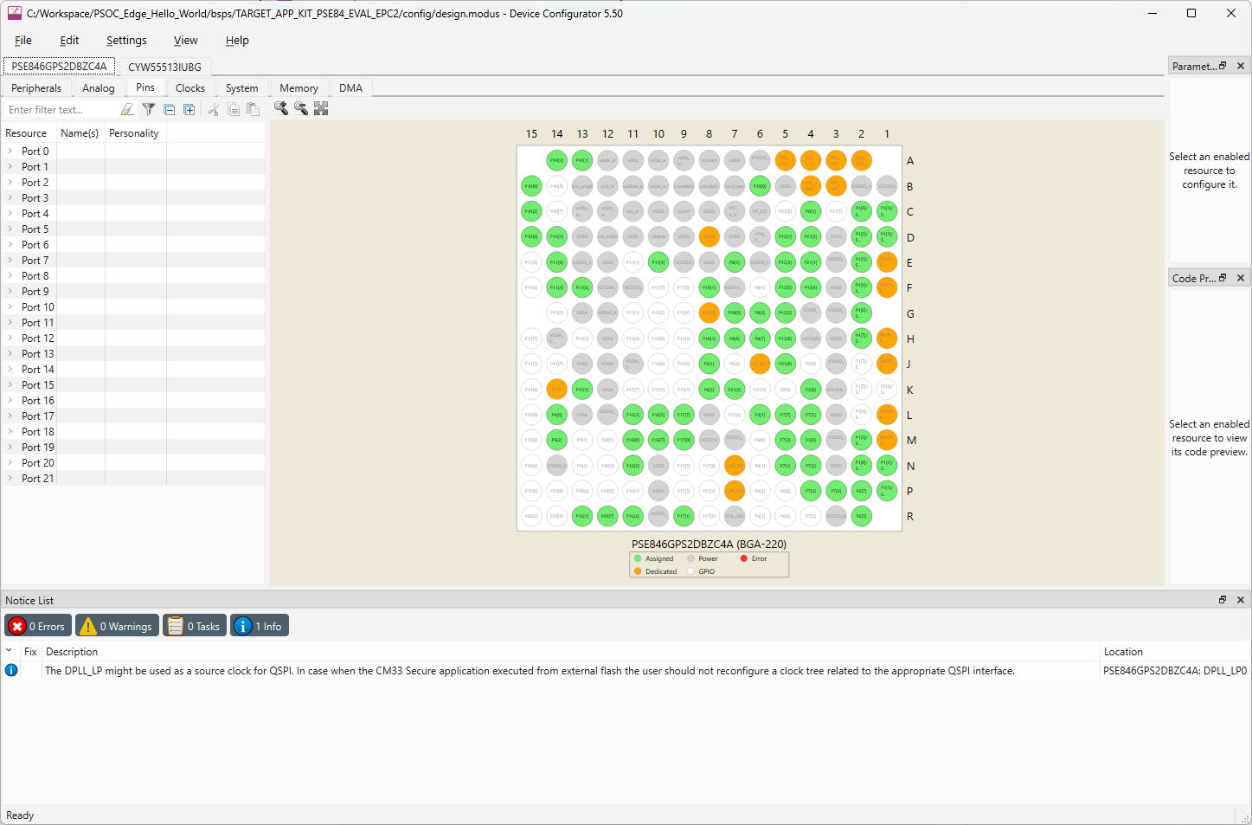
Figure 17 Example figure

- In this particular Development Kit, the three User LEDs are connected to Port 16 Pins 5, 6 and 7 as per schematic

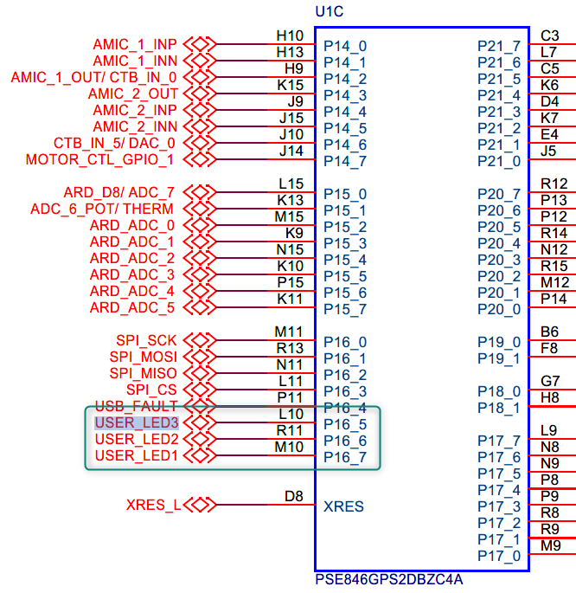
Figure 18 Example figure
Each pin can be uniquely identified by giving them a name of your choice. These names are known as aliases and can be used in the code to refer to the pins instead of using the explicit Pin numbers.

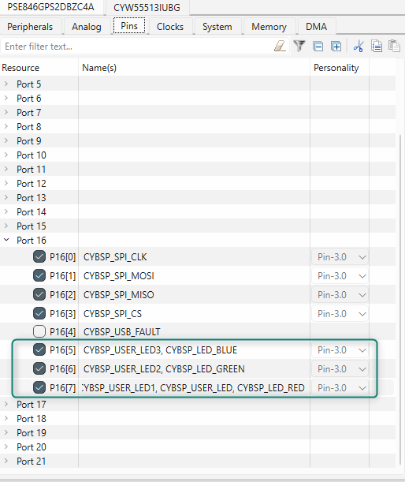
Figure 19 Example figure

- For example, in Figure 20. Device Configurator - Pins – Creating Alias for USER_LED1 we have renamed Port 16 Pin 7 as TRAINING_LED. We will be using this LED in our application. Go to File > Save or alternatively hit Ctrl+S to save the change.

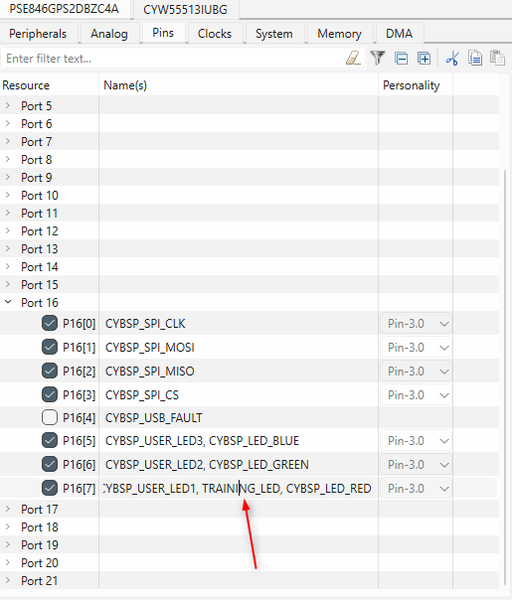
Figure 20. Device Configurator - Pins – Creating Alias for USER_LED1
Similarly let us look at the UART pins required for our PSOC_Edge_Hello_World code example. As per schematic Port 6 Pin 5 is used for UART_RX and Port 6 Pin 7 is used as UART_TX.

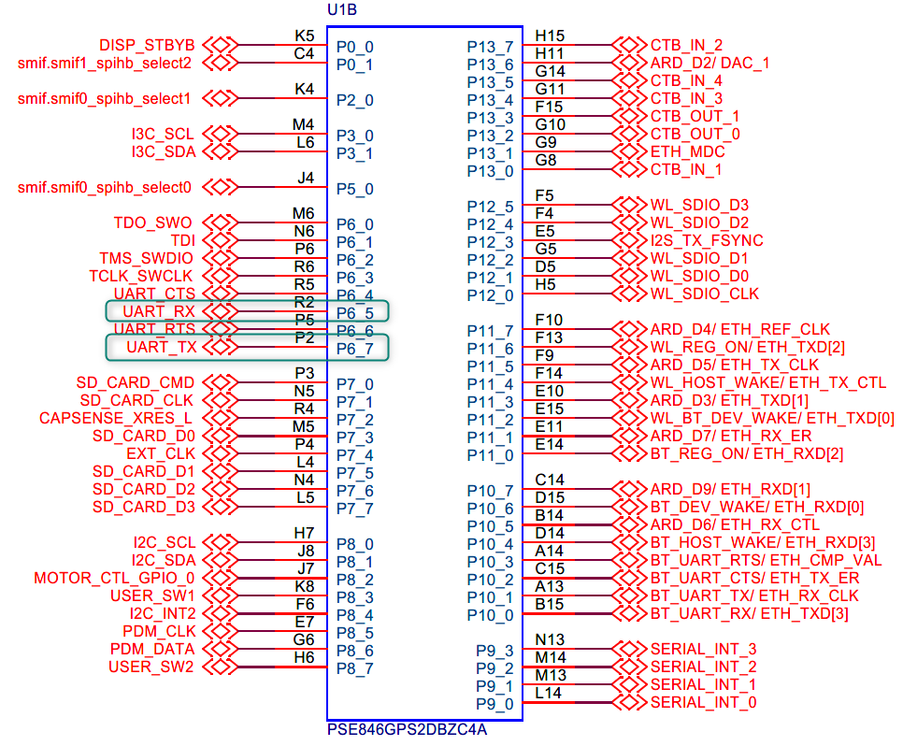
Figure 21 Example figure

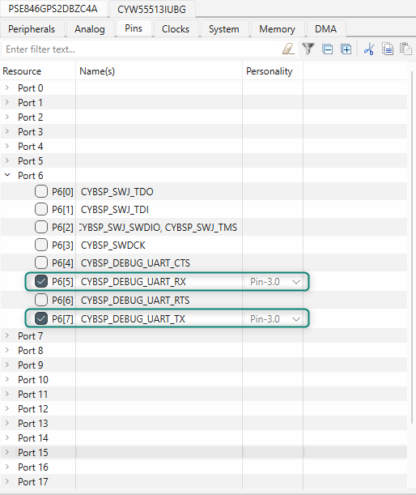
Figure 22 Example figure

Remember these names “CYBSP_DEBUG_UART_TX” and “CYBSP_DEBUG_UART_RX”, as we will be using these during application development .

- Select File > Save to save our changes, and then Close the window to quit the configurator.

- The changes made in the Device Configurator can be see if you open the cycfg_pins.h file. The cycfg_pins.h file, along with all source files that get generated by the Device Configurator can be found GenerateSouce folder under with the application’s bsps folder tree. Figure shows the update. can see the pin definitions and aliases. And the change we have made has been reflected in the file as shown below.

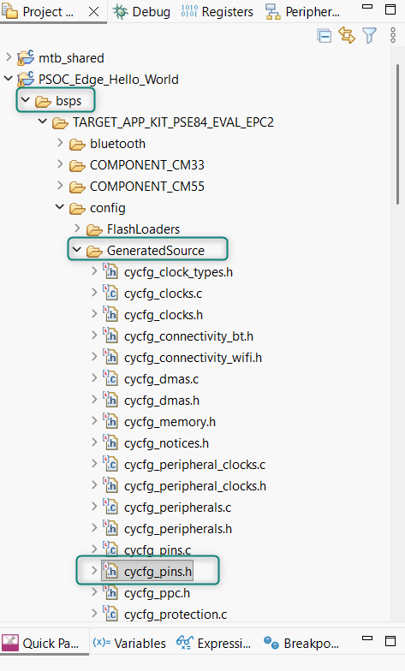
Figure 23 Device Configurator - GeneratedSource folder location with cycfg_pins.h

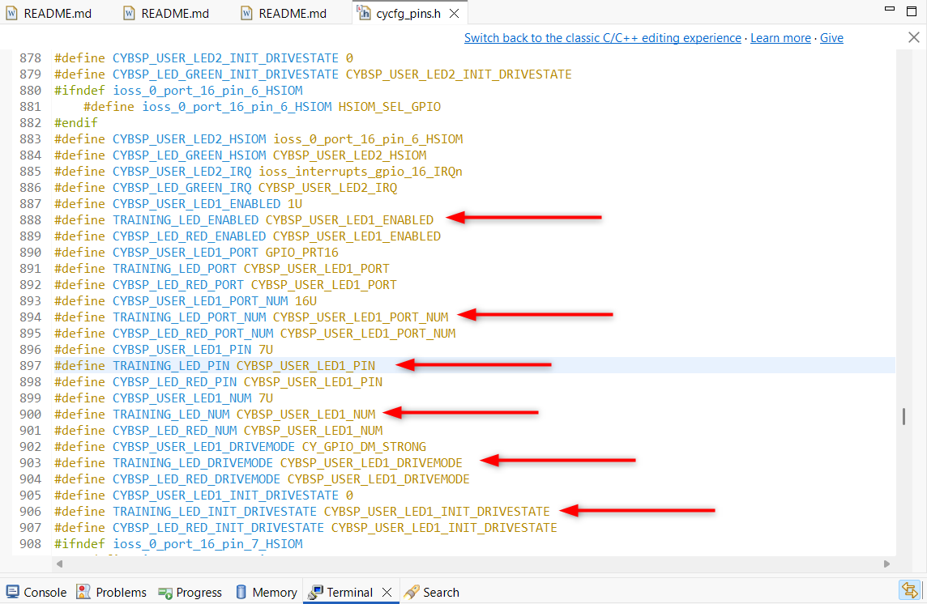
Figure 24 Training_LED Alias in cycfg_pins.h

- In the project explorer you can see two folders named PSOC_Edge_Hello_World.proj_cm33_ns and PSOC_Edge_Hello_World.proj_cm55. Each of these folders will contain a main.c file which contains the application code. Replace these main.c files with main.c template files we have provided. (These Template main.c file has required Macros, definitions and basic initialization.
- Copy the contents from development\templates\PSOC_Edge_Hello_World \main_cm33.c and paste on to PSOC_Edge_Hello_World.proj_cm33_ns main.c
- Copy the contents from development\templates\PSOC_Edge_Hello_World\ main_cm55.c and paste on to PSOC_Edge_Hello_World.proj_cm55 main.c

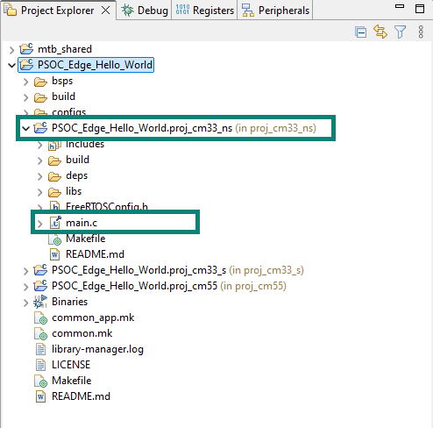

- Remove “FREERTOS RTOS_AWARE” in the COMPONENTS from the proj_cm33_ns and proj_cm55 Makefile
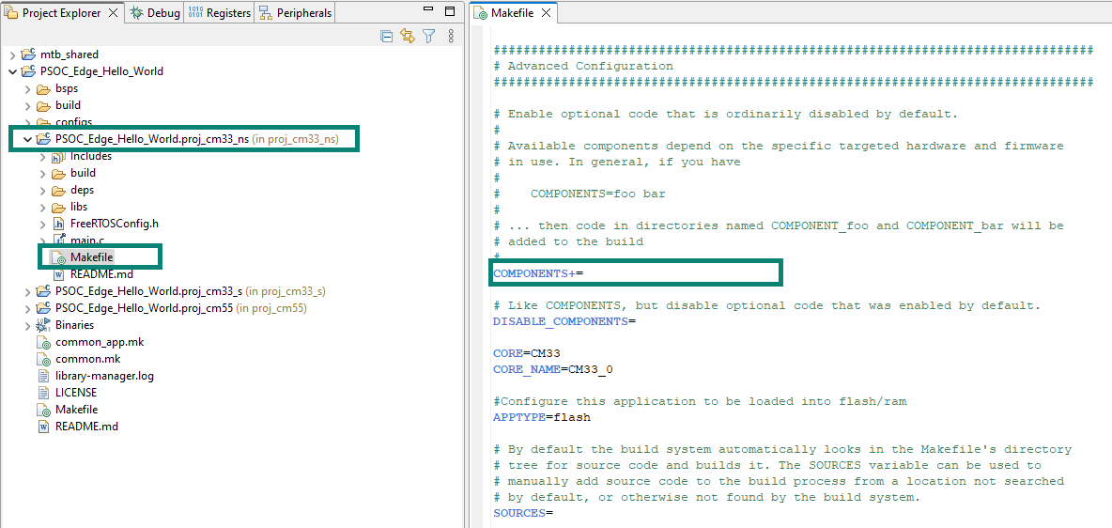
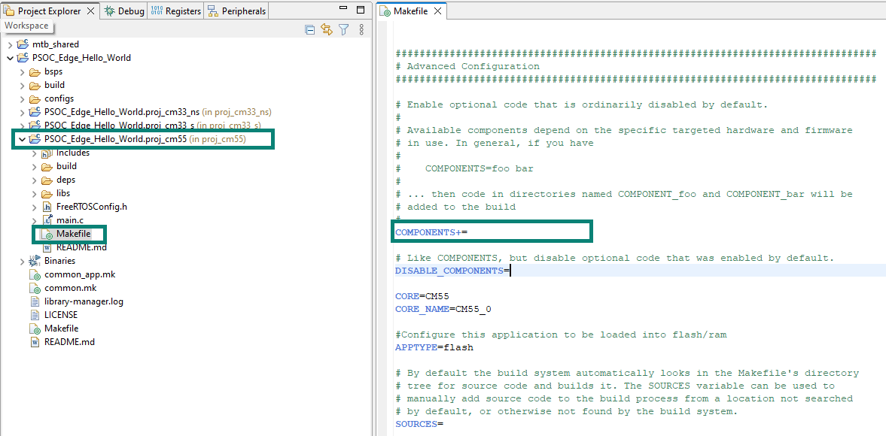

- Build the projects and make sure nothing as broken at this point.
- Now Let’s add the application code
- open the main.c file under PSOC_Edge_Hello_World.proj_cm33_ns. We will be adding the necessary code to this file for CM33 Core
Let us initialize the GPIO for Training LED. The Below code initializes the user LED pin. Copy and paste the below given code inside <code snippet> to the main.c file after __enable_irq();
<code snippet>
/* Initialize LED */
result = cyhal_gpio_init(TRAINING_LED, CYHAL_GPIO_DIR_OUTPUT,
CYHAL_GPIO_DRIVE_STRONG, CYBSP_LED_STATE_OFF);

/* GPIO init failed. Stop program execution */
if (result != CY_RSLT_SUCCESS)
{
CY_ASSERT(0);
}
<code snippet>
The reference for HAL APIs will be available in HAL documentation https://infineon.github.io/mtb-hal-cat1/html/index.html , search for particular function and get an overview of it. Here is an example for the cyhal_gpio_init we used

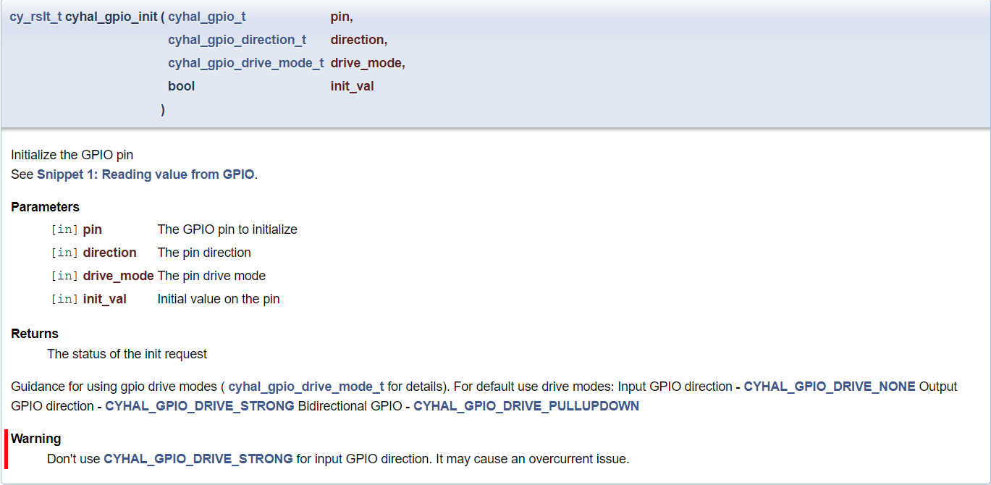

- Let us initialize the UART. The below code sets up retarget-io to use the debug UART port. Copy and paste the below given code inside <code snippet> to the main.c file
<code snippet>
/* Initialize UART */
result = cy_retarget_io_init_fc(CYBSP_DEBUG_UART_TX, CYBSP_DEBUG_UART_RX,
CYBSP_DEBUG_UART_CTS,CYBSP_DEBUG_UART_RTS,
CY_RETARGET_IO_BAUDRATE);

/* retarget-io init failed. Stop program execution */
if (result != CY_RSLT_SUCCESS)
{
CY_ASSERT(0);
}
<code snippet>
- Since we have added a code for UART initialize, lets add some print/Logs to get printed on terminal. Copy and paste the below given code inside <code snippet> to the main.c file
<code snippet>
/* Print hello world */
printf("\x1b[2J\x1b[;H");

printf("****************** "
"PSOC Edge MCU: Hello world using HAL "
"****************** \r\n\n");

printf("Hello World!!!\r\n\n");

printf("For more projects, "
"visit our code examples repositories:\r\n\n");

printf("https://github.com/Infineon/"
"Code-Examples-for-ModusToolbox-Software\r\n\n");
<code snippet>
- We will toggle the LED every 1 second. For generating an interrupt every 1 second we will use Timer Resource. So, we will initialize the timer. Copy and paste the below given code inside <code snippet> to the main.c file.
We will utilize the Uart to get response from the user to control the LED, so we will add info message as well
<code snippet>
/* Initialize timer to toggle the LED */
timer_init();

printf("Press 'Enter' key to pause or "
"resume blinking the user LED \r\n\r\n");
<code snippet>
- We will enable the second core as well using below code snippet. Copy and paste the below given code inside <code snippet> to the main.c file.

<code snippet>
/* Enable CM55 */
Cy_SysEnableCM55(CY_CORTEX_M55_APPL_ADDR, CM55_BOOT_WAIT_TIME_USEC);

<code snippet>
- Now Let’s add the Application code logic
    - First, we will be infinite for loop Polling for the key press entry in the terminal
    - Once User Presses the key, we will verify if the key is “carriage return(\r)”.
    - If It is carriage return, will check for “led_blink_active_flag”, if it set we will stop the timer and pause the LED Toggling
    - Else the LED Toggling Resumes
    - If the received key is not carriage return, we will check for “timer_interrupt_flag”, if it set we will Blink(toggle) the LED.
    - these a to e steps are executed in an infinite loop
As explained below code blinks the LED using the interrupts received from the Timer. Also, it checks whether the Enter key is pressed by the user via UART and pauses or resumes LED blinking based on it.
<code snippet>
/* Main loop */
for (;;)
{
/* Check if 'Enter' key was pressed */
if (cyhal_uart_getc(&cy_retarget_io_uart_obj, &uart_read_value, 1)
== CY_RSLT_SUCCESS)
{
if (uart_read_value == '\r')
{
/* Pause LED blinking by stopping the timer */
if (led_blink_active_flag)
{
cyhal_timer_stop(&led_blink_timer);

printf("LED blinking paused \r\n");
}
else /* Resume LED blinking by starting the timer */
{
cyhal_timer_start(&led_blink_timer);

printf("LED blinking resumed\r\n");
}

/* Move cursor to previous line */
printf("\x1b[1F");

led_blink_active_flag ^= 1;
}
}
/* Check if timer elapsed (interrupt fired) and toggle the LED */
if (timer_interrupt_flag)
{
/* Clear the flag */
timer_interrupt_flag = false;

/* Invert the USER LED state */
cyhal_gpio_toggle(TRAINING_LED);
}
}
<code snippet>
- The timer_init() function prototype was added to main.c, but we haven’t added the function. Copy and paste the below given code inside <code snippet> to main.c below main function.
The below code creates and configures a Timer object. The timer ticks continuously and creates a periodic interrupt on every terminal count. The period is defined by the 'period' and 'compare_value' of the timer configuration structure 'led_blink_timer_cfg'. Without any changes this application is designed to produce an interrupt every 1 second.
<code snippet>
/*******************************************************************************
* Function Name: timer_init
********************************************************************************
* Summary:
* This function creates and configures a Timer object. The timer ticks
* continuously and produces a periodic interrupt on every terminal count
* event. The period is defined by the 'period' and 'compare_value' of the
* timer configuration structure 'led_blink_timer_cfg'. Without any changes,
* this application is designed to produce an interrupt every 1 second.
*
* Parameters:
* none
*
* Return :
* void
*
*******************************************************************************/
void timer_init(void)
{
cy_rslt_t result;

const cyhal_timer_cfg_t led_blink_timer_cfg =
{
.compare_value = 0, /* Timer compare value, not used */
.period = LED_BLINK_TIMER_PERIOD, /* Defines the timer period */
.direction = CYHAL_TIMER_DIR_UP, /* Timer counts up */
.is_compare = false, /* Don't use compare mode */
.is_continuous = true, /* Run timer indefinitely */
.value = 0 /* Initial value of counter */
};

/* Initialize the timer object. Does not use input pin ('pin' is NC) and
* does not use a pre-configured clock source ('clk' is NULL). */
result = cyhal_timer_init(&led_blink_timer, NC, NULL);

/* timer init failed. Stop program execution */
if (result != CY_RSLT_SUCCESS)
{
CY_ASSERT(0);
}

/* Configure timer period and operation mode such as count direction,
duration */
cyhal_timer_configure(&led_blink_timer, &led_blink_timer_cfg);

/* Set the frequency of timer's clock source */
cyhal_timer_set_frequency(&led_blink_timer, LED_BLINK_TIMER_CLOCK_HZ);

/* Assign the ISR to execute on timer interrupt */
cyhal_timer_register_callback(&led_blink_timer, isr_timer, NULL);

/* Set the event on which timer interrupt occurs and enable it */
cyhal_timer_enable_event(&led_blink_timer, CYHAL_TIMER_IRQ_TERMINAL_COUNT,
7, true);

/* Start the timer with the configured settings */
cyhal_timer_start(&led_blink_timer);
}
<code snippet>

- Let’s add the interrupt handler function for the timer. Copy and paste the below given code inside <code snippet> to the main.c file below timer_init function.

<code snippet>
/*******************************************************************************
* Function Name: isr_timer
********************************************************************************
* Summary:
* This is the interrupt handler function for the timer interrupt.
*
* Parameters:
* callback_arg Arguments passed to the interrupt callback
* event Timer/counter interrupt triggers
*
* Return:
* void
*******************************************************************************/
static void isr_timer(void *callback_arg, cyhal_timer_event_t event)
{
(void) callback_arg;
(void) event;

/* Set the interrupt flag and process it from the main while(1) loop */
timer_interrupt_flag = true;
}
<code snippet>

- Save the file. We are done with adding the application code for PSOC_Edge_Hello_World.proj_cm33_ns
- Let’s add the application code for PSOC_Edge_Hello_World.proj_cm55. Open main.c under PSOC_Edge_Hello_World.proj_cm55 and put the CM55 core to system deep sleep, as we are not performing any task in this core. Copy and paste the below given code inside <code snippet> to the PSOC_Edge_Hello_World.proj_cm55 main.c after __enable_irq();
<code snippet>
/* Put the CPU to deepsleep */
for (;;)
{
cyhal_syspm_deepsleep();
}
<code snippet>

- Save the file. We are done with adding the application code to both cores
- Let’s build by clicking on the Build Application option in the Quick Panel.
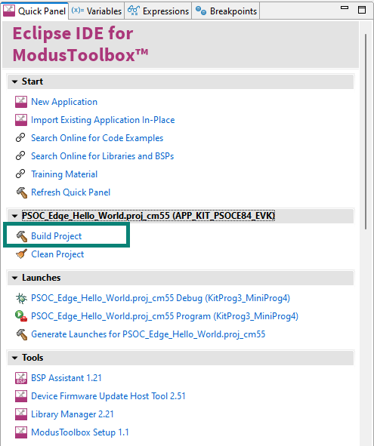
- After the Build process is successfully completed. We can program the board by clicking the Launch button in the Quick Panel.

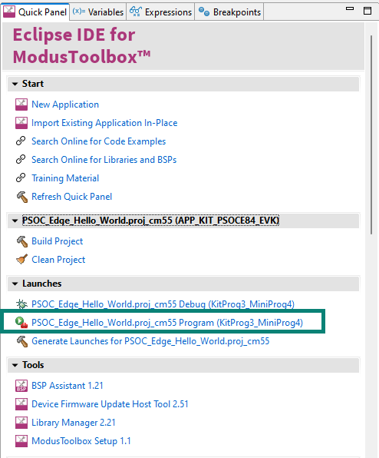
- After programing is successful, Open the serial Terminal and configure as baud rate 115200 8-N-1 then restart the dev kit. You will see the message as shown in below image and kit LED blinks at approximately 1 Hz. Press Enter Key to Pause and resume the LED Blinking respectively.
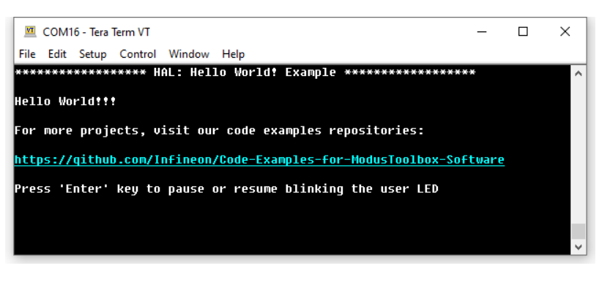
  - Conclusion
We successfully created first PSOC™ Edge E84 application using ModusToolbox™, figured out to use HAL Libraries, Print Logs on terminals and blink LED every 1 second using Timer

- Code Example 2: IPC queues using HAL

Objective
This code example demonstrates how to use the inter-processor communication (IPC) HAL driver to implement a message queue in PSOC™ Edge MCU. The queues are used to send messages between CPUs.

Description
In this code example, the CM55 CPU is the primary CPU, which is responsible to initialize the system. To avoid any access to uninitialized hardware, CM33 waits for CM55 to complete the system initialization by waiting for an IPC command.
This code example handles four types of IPC commands:
IPC_CMD_INIT: CM33 waits for this command to initialize.
IPC_CMD_START: CM33 waits for this command to enable a watchdog timer and the Crypto block.
IPC_CMD_STOP: CM33 waits for this command to disable a watchdog timer and the Crypto block.
The CM33 CPU uses a watchdog timer to periodically wake itself up from sleep. Once it wakes up, it generates a 32-bit random number using the crypto block and sends it to the CM55 CPU.
The CM55 CPU checks if the user has pressed the kit button. When a button press is detected, CM55 informs CM33 to start creating random numbers. When the button is released, CM55 instructs CM33 to stop creating random numbers. When CM55 receives a message from CM33, it parses it, and prints the random number to the terminal.
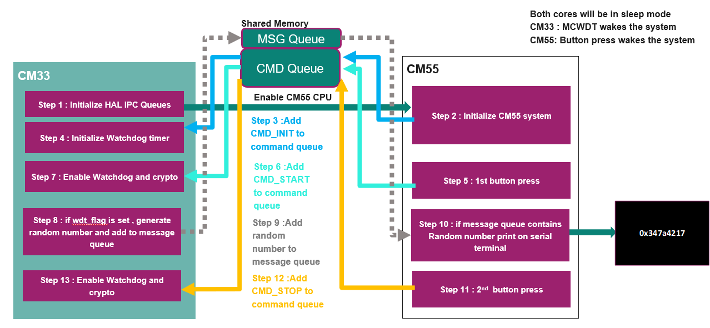

Flowchart

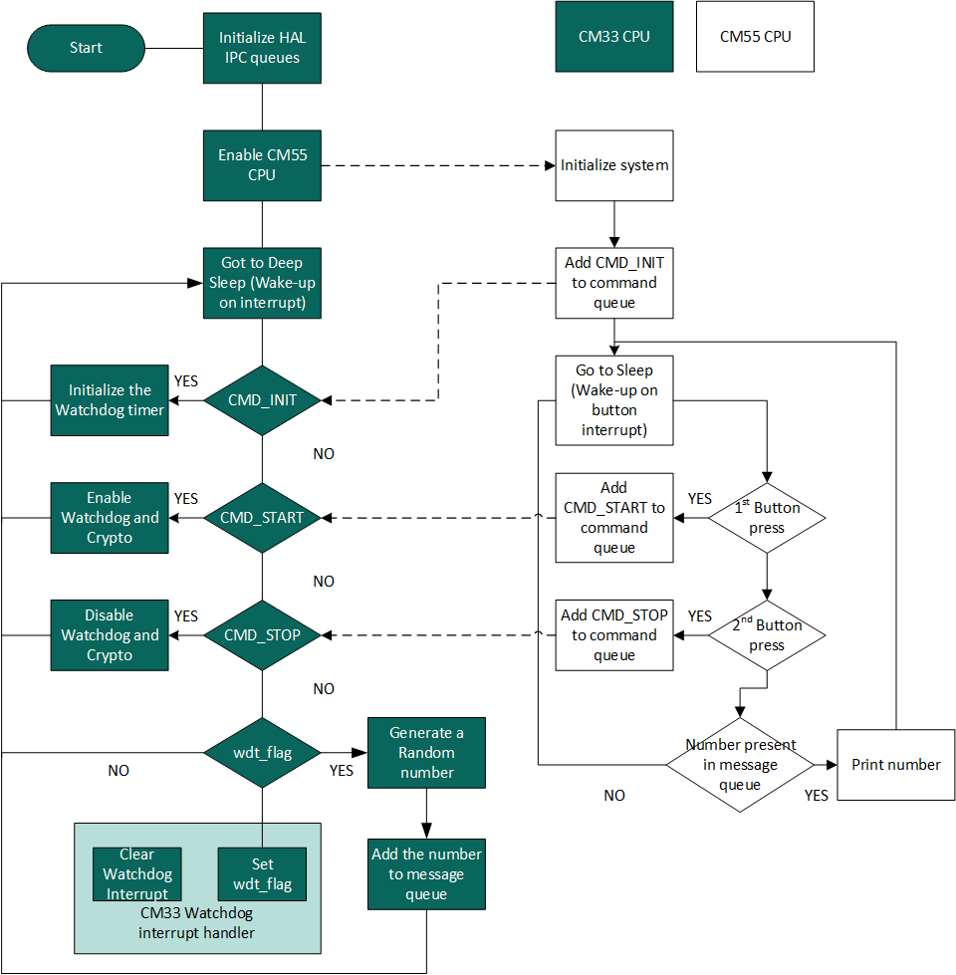

Hardware Block Diagram
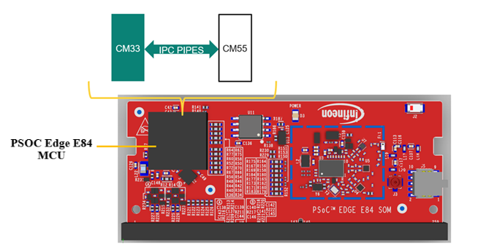

Hardware Setup

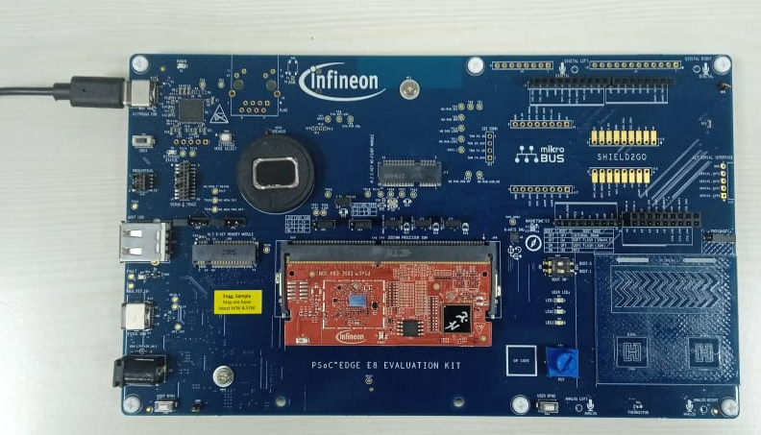

Project Creation
- Since we are already familiar with the project creation process, we will start by creating a New Application.
We will start with a Hello World application and turn it into an IPC queues using HAL application.
- Click New Application from the Quick Panel. Alternatively, go to File> New> Modus Toolbox™ Application
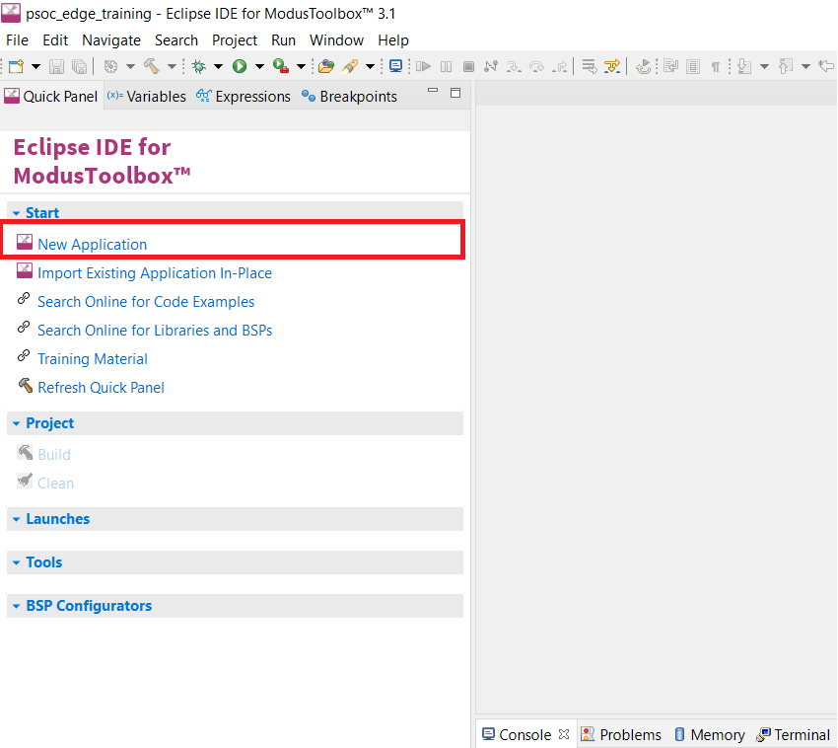
- Clicking New Application will open the Project Creator Tool and prompt you to choose a BSP (Board Support Package).
- Once Projector creator launches, Select the KIT_PSOCE84_EVK BSP under the PSOC™ Edge BSPs. Then click Next.
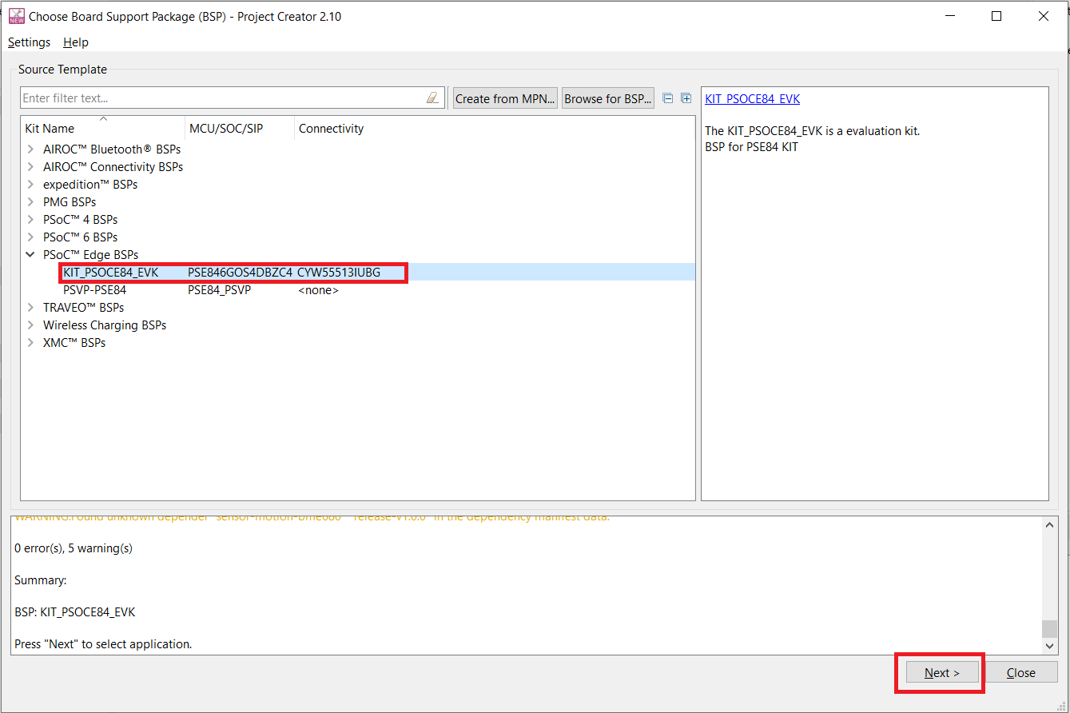

- Clicking Next will take you to the next menu of the Project Creator which will ask you to select an application. Select the PSOC Edge Hello World under the Getting Started section. You can do this by selecting the checkbox near the application. Change the name to “PSOC_Edge_Hal_IPC_Queue” as we will be developing the Hello World application into a dual-core IPC application.
- Click on Create.
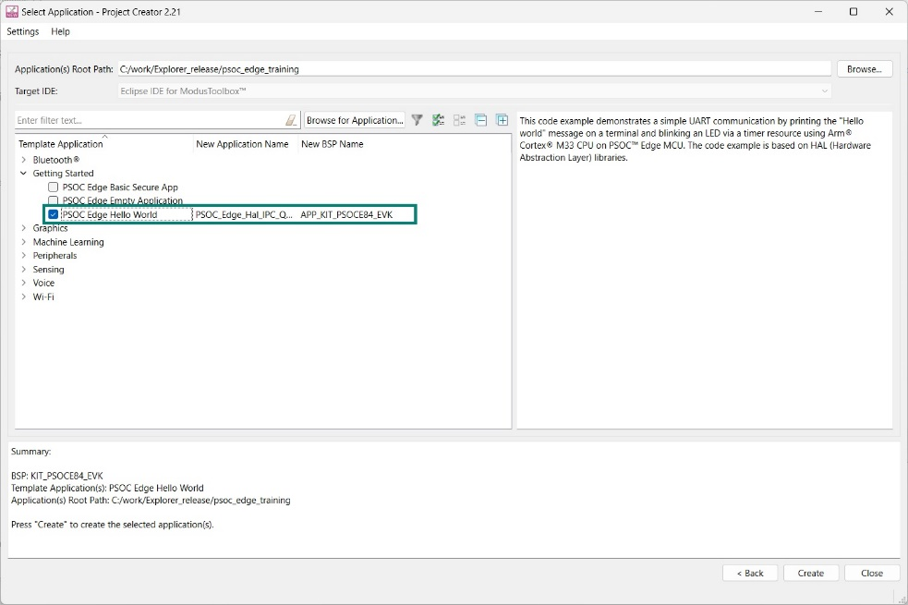
- If you expand the main project folder, you can see that there are multiple sub-folders within it.
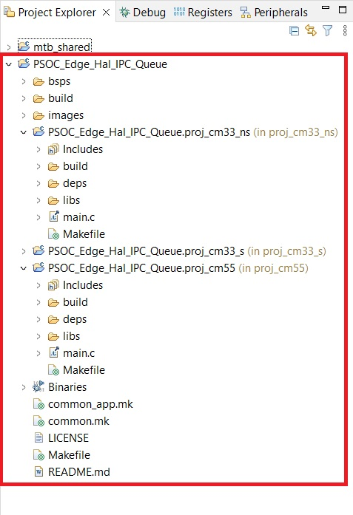

Helloworld project uses the retargetIO in proj_cm33_ns. We will remove it using the Library Manager Tool. Library Manager can be found in the Quick Panel. Also, retargetIO is needed for our project for using the UART functionalities in proj_cm55. This too can be added using the Library Manager.
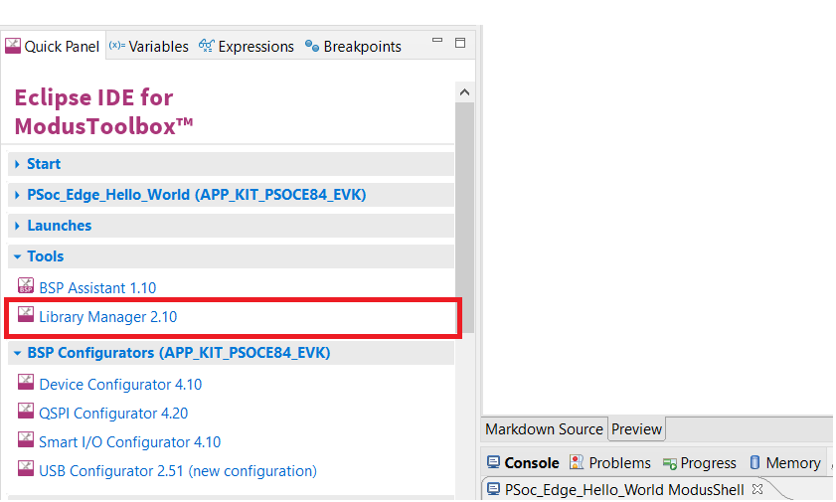
- Select the PSOC_Edge_Hal_IPC_Queue Project in the mtb project explorer and Open the Library Manager from quick panel. You would be able to see the retargetIO under the proj_cm33_ns. Click the ‘X’ mark to remove the library.

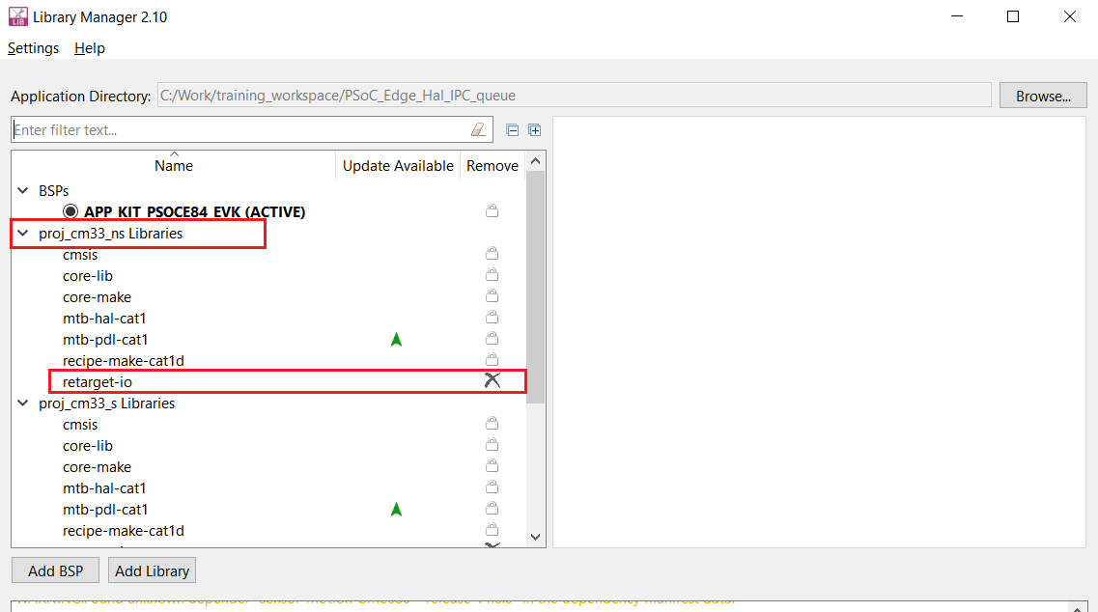

Now, click the Add Library option. A menu will open. Change the Target Project to proj_cm55 and Search for retarget-io. It can be found under the Peripheral section. Select the retarget-io option and click OK.

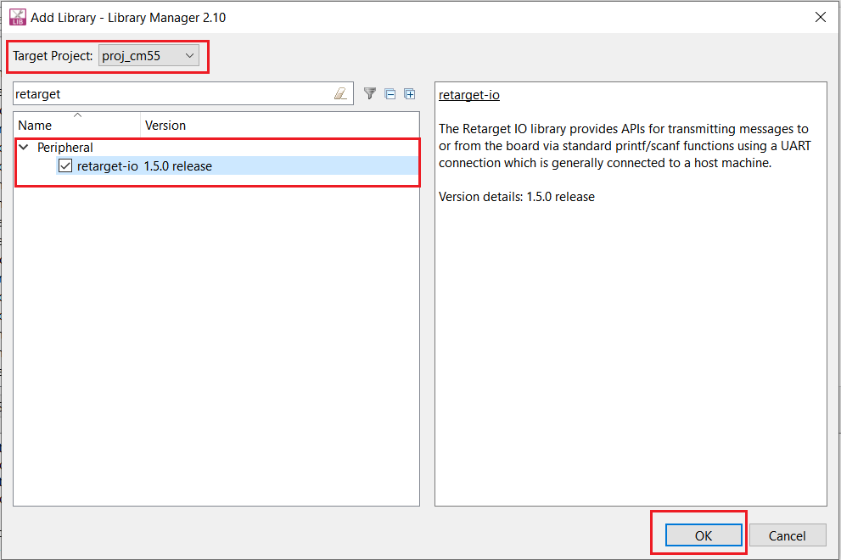

Now, click Update on the Library Manager.

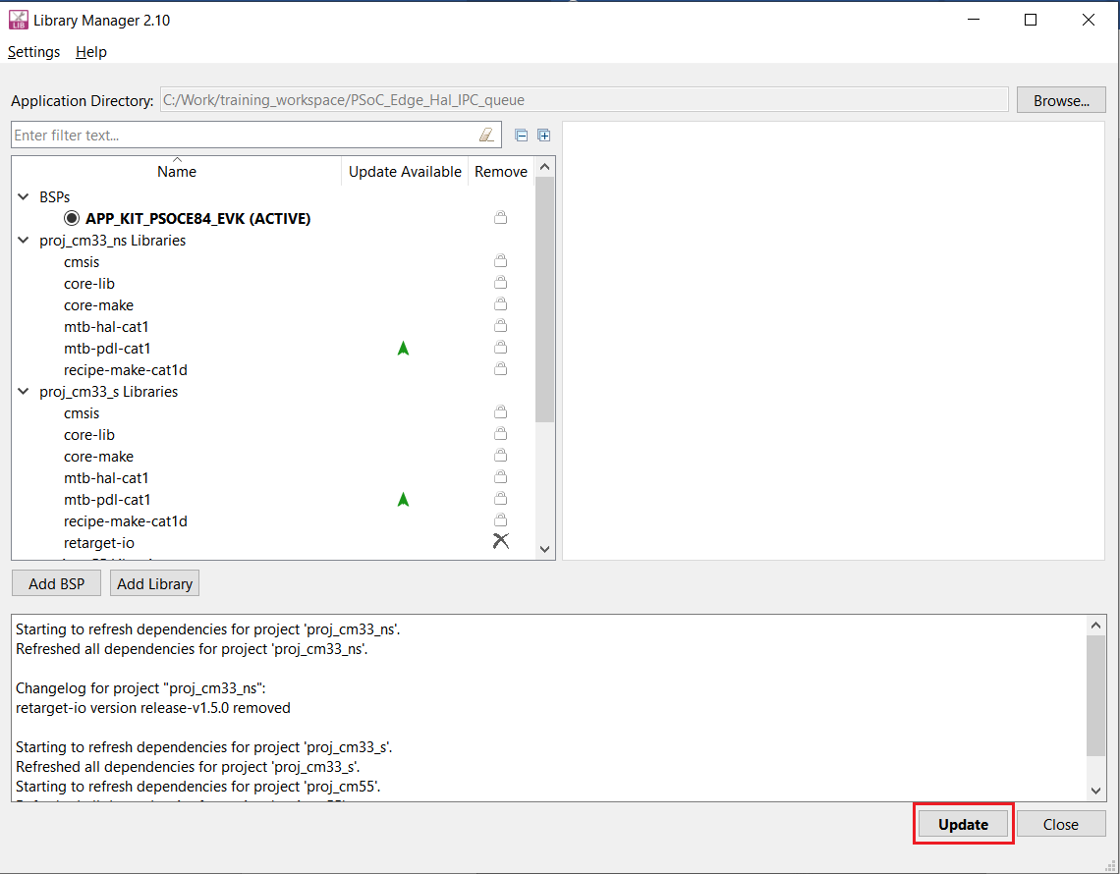

- Library Manger will update all the changes made to the Hal IPC Queue project
- In the project explorer you can see two folders named PSOC_Edge_Hal_IPC_Queue.proj_cm33_ns and PSOC_Edge_Hal_IPC_Queue.proj_cm55. Each of these folders will contain a main.c file which contains the application code. Replace these main.c files with main.c template files we have provided. (These Template main.c file has required Macros, definitions and basic initialization.
Copy the contents from development\templates\ PSOC_Edge_Hal_IPC_Queue\main_cm33.c and paste on to PSOC_Edge_Hal_IPC_Queue.proj_cm33_ns main.c
Copy the contents from development\templates\ PSOC_Edge_Hal_IPC_Queue \main_cm55.c and paste on to PSOC_Edge_Hal_IPC_Queue.proj_cm55. main.c
- Build the projects and make sure nothing as broken at this point.
- Now Let’s add the application code.
- Copy shared folder from development\templates\PSOC_Edge_Hal_IPC_Queue\ and paste to your created PSOC_Edge_Hal_IPC_Queue folder
This shared folder contains the “ipc_communication.h” file, which contains definitions of constants and structures for setting up user pipe and function prototypes for configuring system and user IPC pipe
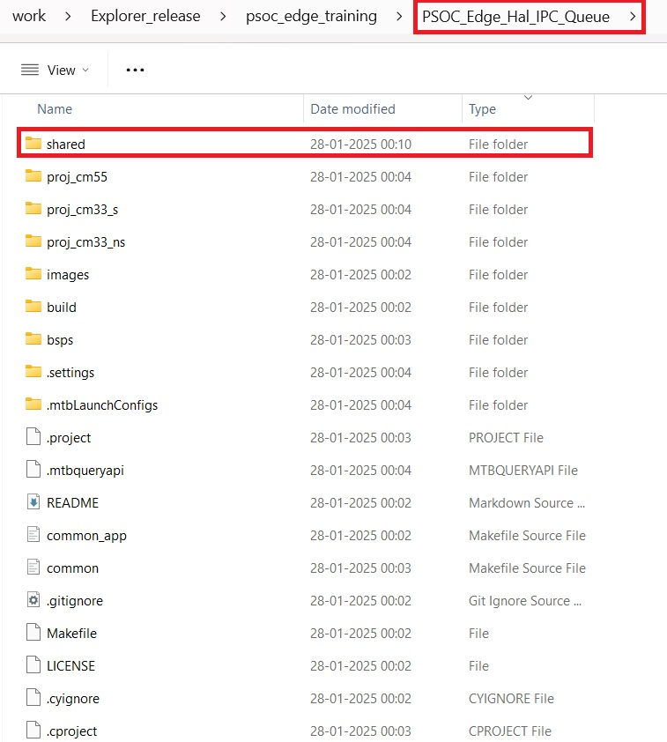
- Let’s modify the Makefile to include “ipc_communication.h” file, open Makefile for project PSOC_Edge_Hal_IPC_Queue.proj_cm33_ns
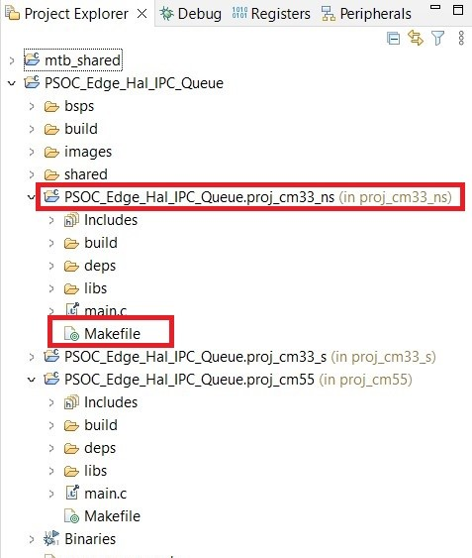
- Change the INCLUDES= to INCLUDES=../shared/include in Makefile and Save the file
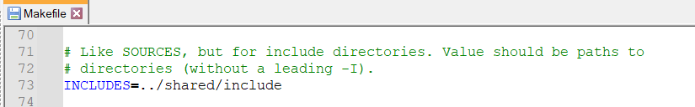
- Similarly lets modified the Makefile to include “ipc_communication.h” file, open Makefile for project PSOC_Edge_Hal_IPC_Queue.proj_cm55
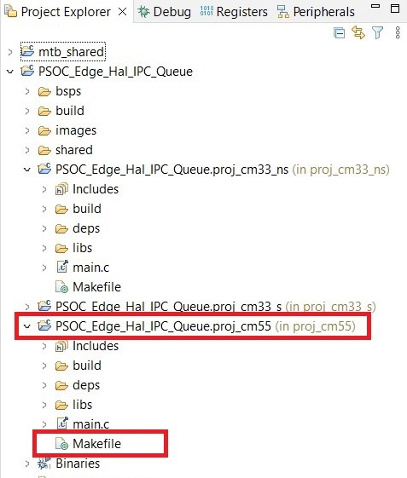
- Change the INCLUDES= to INCLUDES=../shared/include in Makefile and Save the file
- Open the main.c file under PSOC_Edge_Hal_IPC_Queue.proj_cm33_ns. We will be adding the necessary code to this file for CM33 Core.
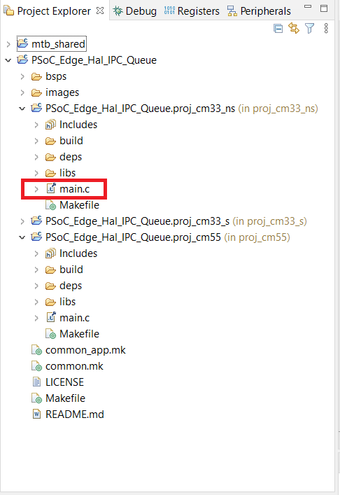
- Defines some Macros and add IPC communication header file to the main.c
Copy and paste the below given code inside <code snippet> to the main.c file after #includes
<code snippet>
#include "cy_pdl.h"
#include "cyhal.h"
#include "cybsp.h"
#include "ipc_communication.h"

/*****************************************************************************
* Macros
*****************************************************************************/
#define MCWDT_HW MCWDT_STRUCT0
#define CM55_BOOT_WAIT_TIME_US 10u
#define MCWDT_IRQ_PRIORITY (2U)
#define MCWDT_WAIT_TIME (0U)
#define WDT_FLAG_SET (1)
#define WDT_FLAG_RESET (0)

/* TRNG constants */
#define GARO31_INITSTATE (0x04c11db7)
#define FIRO31_INITSTATE (0x04c11db7)
#define MAX_TRNG_BIT_SIZE (32UL)
<code snippet>
- Copy and paste the below given code inside <code snippet> to the main.c file under function declaration or above main function
The below code is for the configuration of the Watchdog Timer
<code snippet>
/*****************************************************************************
* Global Variables
*****************************************************************************/
static const cy_stc_sysint_t mcwdt_flag_cfg =
{
.intrSrc = srss_interrupt_mcwdt_0_IRQn,
.intrPriority = MCWDT_IRQ_PRIORITY
};

/* Watchdog timer configuration */
static const cy_stc_mcwdt_config_t mcwdt_cfg =
{
.c0Match = 32768,
.c1Match = 32768,
.c0Mode = CY_MCWDT_MODE_INT,
.c1Mode = CY_MCWDT_MODE_NONE ,
.c2ToggleBit = 16,
.c2Mode = CY_MCWDT_MODE_NONE ,
.c0ClearOnMatch = true,
.c1ClearOnMatch = false,
.c0c1Cascade = false,
.c1c2Cascade = false,
.c0LowerLimitMode = CY_MCWDT_LOWER_LIMIT_MODE_NOTHING,
.c0LowerLimit = 0U,
.c1LowerLimitMode = CY_MCWDT_LOWER_LIMIT_MODE_NOTHING,
.c1LowerLimit = 0U
};

/* Global variable to detect MCWDT ISR handler execution */
volatile int wdt_flag = WDT_FLAG_RESET;

/*****************************************************************************
* Function Prototypes
*****************************************************************************/
static void mcwdt_handler(void);

<code snippet>
- Let’s declare the variables for MCWDT, crypto, IPC queues
Copy and paste the below given code inside <code snippet> to the main.c file inside main function before result = cybsp_init();
The below code is the variables required for the communication between the cores:
<code snippet>
/*****************************************************************************
* Function Name: main
******************************************************************************
int main(void)
{
/* Local variables */
cy_rslt_t result;
cy_en_mcwdt_status_t mcwdt_status;
cy_en_sysint_status_t sysint_status;
cy_en_crypto_status_t crypt_status;
cyhal_ipc_t task0_queue1;
cyhal_ipc_t task0_queue2;
void *queue1_pool, *queue2_pool;
cyhal_ipc_queue_t *queue1_handle, *queue2_handle;

uint32_t random_number;
uint32_t task0_msg = 0; // Value to be sent to the other core.
uint32_t task0_cmd = 0;

<code snippet>
- Let’s define and allocate shared memory pools for IPC queues, we will be using 2 queues one for command task and another for message task
Copy and paste the below given code inside <code snippet> to the main.c file inside main function after __enable_irq();
The below code defines and allocates the shared memory pools for queue 1 and queue 2.
<code snippet>
/* Allocating (shared) memory pools for queue1 and queue2 */
CYHAL_IPC_QUEUE_POOL_ALLOC(queue1_pool, QUEUE1_ITEMS, sizeof(task0_cmd));
CYHAL_IPC_QUEUE_POOL_ALLOC(queue2_pool, QUEUE2_ITEMS, sizeof(task0_msg));
<code snippet>
- Let’s fill in the data for the queue handlers
Copy and paste the below given code inside <code snippet> to the main.c file inside main function after queue defines
The below code defines and allocates shared memory for the queue handles
<code snippet>
/* Allocating (shared) memory for queue handles and initialize handles*/
CYHAL_IPC_QUEUE_HANDLE_ALLOC(queue1_handle);
CYHAL_IPC_QUEUE_HANDLE_ALLOC(queue2_handle);

queue1_handle->channel_num = CMD_CHANNEL_NUM;
queue1_handle->queue_num = QUEUE1_NUM;
queue1_handle->queue_pool = queue1_pool;
queue1_handle->num_items = QUEUE1_ITEMS;
queue1_handle->item_size = sizeof(task0_cmd);

queue2_handle->channel_num = MSG_CHANNEL_NUM;
queue2_handle->queue_num = QUEUE2_NUM;
queue2_handle->queue_pool = queue2_pool;
queue2_handle->num_items = QUEUE2_ITEMS;
queue2_handle->item_size = sizeof(task0_msg);
<code snippet>
- Initialize the IPC queues and enable the IPC queue
Copy and paste the below given code inside <code snippet> to the main.c file inside main function after queue handlers
The below code defines and allocates shared memory for the queue handles
<code snippet>
/* Init IPC queues */
result = cyhal_ipc_queue_init(&task0_queue1, queue1_handle);
if (CY_RSLT_SUCCESS != result)
{
CY_ASSERT(0);
}

result = cyhal_ipc_queue_init(&task0_queue2, queue2_handle);
if (CY_RSLT_SUCCESS != result)
{
CY_ASSERT(0);
}

cyhal_ipc_queue_enable_event(&task0_queue1, CYHAL_IPC_QUEUE_WRITE, (uint8_t)IPC_QUEUE_IRQ_PRIORITY, true);

<code snippet>
- We will enable the second core as well using below code sinppet. Copy and paste the below given code inside <code snippet> to the main.c file
The below code enables the CM55 core
<code snippet>
/* Enable CM55. CY_CORTEX_M55_APPL_ADDR must be updated if CM55 memory layout is changed. */
Cy_SysEnableCM55(CY_CM55_APP_BOOT_ADDR, CM55_BOOT_WAIT_TIME_US);
<code snippet>
- We will create an infinite loop and state machine using switch containing IPC_CMD_INIT, IPC_CMD_START and IPC_CMD_STOP which will initialize MCWDT in IPC_CMD_INIT, Enable MCWDT and Crypto in IPC_CMD_START and Disable MCWDT and Crypto in IPC_CMD_STOP
- IPC_CMD_INIT: CM33 waits for this command from CM55 to initialize.
- IPC_CMD_START: CM33 waits for this command from CM55 to enable a watchdog timer and the Crypto block.
- IPC_CMD_STOP: CM33 waits for this command from CM55 to disable a watchdog timer and the Crypto block
- System is put under deep sleep, MCWDT interrupt will wake the CM33 core for random generation
Copy and paste the below given code inside <code snippet> to the main.c file after enabling CM55
The below code will initialize and enable Multi-Counter Watchdog Timer (MCWDT) and enables the crypto core which will be used for generating random numbers:
<code snippet>
/* Main loop */
for(;;)
{
cyhal_syspm_deepsleep();

if (cyhal_ipc_queue_count(&task0_queue1))
{
result = cyhal_ipc_queue_get(&task0_queue1, &task0_cmd, CYHAL_IPC_NEVER_TIMEOUT);
if (CY_RSLT_SUCCESS != result)
{
CY_ASSERT(0);
}

switch (task0_cmd)
{

case IPC_CMD_INIT:

SystemCoreClockUpdate();

sysint_status = Cy_SysInt_Init(&mcwdt_flag_cfg, mcwdt_handler);
if (CY_SYSINT_SUCCESS != sysint_status)
{
CY_ASSERT(0);
}
NVIC_ClearPendingIRQ((IRQn_Type) mcwdt_flag_cfg.intrSrc);
NVIC_EnableIRQ((IRQn_Type) mcwdt_flag_cfg.intrSrc);

mcwdt_status = Cy_MCWDT_Init(MCWDT_HW, &mcwdt_cfg);
if (CY_MCWDT_SUCCESS != mcwdt_status)
{
CY_ASSERT(0);
}
Cy_MCWDT_SetInterruptMask(MCWDT_HW, CY_MCWDT_CTR0);
task0_cmd = IPC_CMD_DEFAULT;

break;

case IPC_CMD_START:
Cy_MCWDT_Enable(MCWDT_HW, CY_MCWDT_CTR0, MCWDT_WAIT_TIME);
crypt_status = Cy_Crypto_Core_Enable(CRYPTO);
if (CY_CRYPTO_SUCCESS != crypt_status)
{
CY_ASSERT(0);
}

task0_cmd = IPC_CMD_DEFAULT;

break;

case IPC_CMD_STOP:
Cy_MCWDT_Disable(MCWDT_HW, CY_MCWDT_CTR0, MCWDT_WAIT_TIME);
crypt_status = Cy_Crypto_Core_Disable(CRYPTO);
if (CY_CRYPTO_SUCCESS != crypt_status)
{
CY_ASSERT(0);
}

wdt_flag = WDT_FLAG_RESET;
task0_cmd = IPC_CMD_DEFAULT;

break;

default:
break;
}

} /* if (cyhal_ipc_queue_count(&task0_queue1)) */

<code snippet>
- Add a code to check the MCWDT interrupt and generate random number using crypto
Copy and paste the below given code inside <code snippet> to the main.c file after infinite for loop. The below code checks for the occurrence of interrupt from the MCWDT and then generates a random number using the crypto core. After this the random number is sent to the CM55 core to be printed when CM55 requests
<code snippet>
/* Check if MCWDT interrupt has occurred. */
if (wdt_flag)
{
/* Generate a random number */
crypt_status = Cy_Crypto_Core_Trng(CRYPTO, GARO31_INITSTATE,
FIRO31_INITSTATE,
MAX_TRNG_BIT_SIZE, &random_number);
if (CY_CRYPTO_SUCCESS != crypt_status)
{
CY_ASSERT(0);
}

/* Send the random number to CM55 to be printed */
task0_msg = random_number;
result = cyhal_ipc_queue_put(&task0_queue2, &task0_msg, CYHAL_IPC_NEVER_TIMEOUT);
if (CY_RSLT_SUCCESS != result)
{
CY_ASSERT(0);
}

wdt_flag = WDT_FLAG_RESET;
}
} /* End for loop */

<code snippet>
- Add a code to handle the MCWDT interrupt, where the wdt_flag will be set, these flags will be monitored to generate random number
Copy and paste the below given code inside <code snippet> to the main.c file after main function
The below code is for a Watchdog timer handler that periodically wakes up the CM33 core:
<code snippet>
/*******************************************************************************
* Function Name: mcwdt_handler
********************************************************************************
* Summary:
* Watchdog handler to periodically wake up the CM33.
*
*******************************************************************************/
static void mcwdt_handler(void)
{
uint32 mcwdtIsrMask;

/* Get the Watchdog Interrupt Status */
mcwdtIsrMask = Cy_MCWDT_GetInterruptStatus(MCWDT_HW);

if(CY_MCWDT_CTR0 & mcwdtIsrMask)
{
/* Clear Watchdog Interrupt */
Cy_MCWDT_ClearInterrupt(MCWDT_HW, CY_MCWDT_CTR0);

wdt_flag = WDT_FLAG_SET;
}
}
<code snippet>
- Save the file. We are done with adding the application code for PSOC_Edge_Hal_IPC_Queue.proj_cm33_ns
- Now we need to add the code that runs on the CM55 core. For this Open the main.c file under PSOC_Edge_Hal_IPC_Queue.proj_cm55. We will be adding the necessary code to this file for CM55 Core.
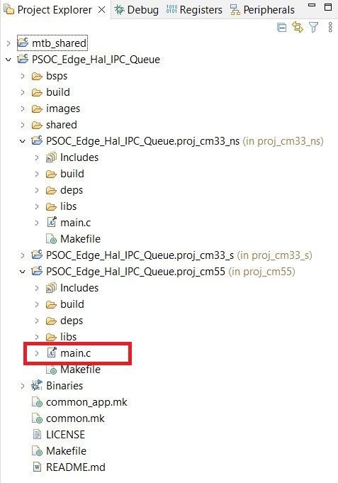
- Defines some Macros and add IPC communication header file to the main.c
Copy and paste the below given code inside <code snippet> to the main.c file after #includes
<code snippet>
#include "cy_pdl.h"
#include "cyhal.h"
#include "cybsp.h"
#include "cy_retarget_io.h"
#include "ipc_communication.h"

/*****************************************************************************
* Macros
*****************************************************************************/
#define BTN_INIT_VAL (0U)
#define BTN_MSG_START (1U)
#define BTN_MSG_STOP (2U)
#define BTN_DEBOUNCE_DELAY_MS (100U)

/*****************************************************************************
* Global Variables
*****************************************************************************/
/* Message variables */
static volatile bool button_flag ;
static volatile bool button_pressed ;
static volatile uint32_t button_status = BTN_INIT_VAL;
<code snippet>
- Add function definitions and prototypes for button
Copy and paste the below given code inside <code snippet> to the main.c file after global variable definitions
<code snippet>
/*****************************************************************************
* Function Prototypes
*****************************************************************************/
static void button_isr_handler(void *arg, cyhal_gpio_event_t event);

/*****************************************************************************
* Function Definitions
*****************************************************************************/
static cyhal_gpio_callback_data_t cb_data =
{
.callback = button_isr_handler,
.callback_arg = NULL
};

/* MCWDT Object [used by CM33] */
static cyhal_resource_inst_t mcwdt_0 =
{
.type = CYHAL_RSC_LPTIMER,
.block_num = 0
};
<code snippet>
- Let’s declare the variables for queues
Copy and paste the below given code inside <code snippet> to the main.c file inside main function before result = cybsp_init();
The below code is the variables required for the communication between the cores:
<code snippet>
int main(void)
{
/* Local variables */
cy_rslt_t result;
cyhal_ipc_t task1_queue1;
cyhal_ipc_t task1_queue2;

uint32_t task1_cmd;
uint32_t task1_msg;
<code snippet>
- Reserve the MCWDT used by the CM33 to avoid conflicts if a LPTIMER is to be added in the CM55
Copy and paste the below given code inside <code snippet> to the main.c file above __enable_irq
The below code reserves the MCWDT used by the CM33 core so that there are no conflicts if an LPTIMER is to be added to the CM55 core:
<code snippet>
/* Reserve the MCWDT used by the CM33 to avoid conflicts if a LPTIMER is
to be added in the CM55 */
result = cyhal_hwmgr_reserve(&mcwdt_0);
if (CY_RSLT_SUCCESS != result)
{
CY_ASSERT(0);
}
<code snippet>
- Initialize the Retarget IO
Copy and paste the below given code inside <code snippet> to the main.c file below __enable_irq
The below code initializes retarget-io to use the debug UART port:
<code snippet>
/* Initialize retarget-io to use the debug UART port */
result = cy_retarget_io_init(CYBSP_DEBUG_UART_TX, CYBSP_DEBUG_UART_RX, CY_RETARGET_IO_BAUDRATE);
if (CY_RSLT_SUCCESS != result)
{
CY_ASSERT(0);
}
<code snippet>
- Initialize and the User Button
Copy and paste the below given code inside <code snippet> to the main.c file below retarget_io init
The below code initializes and configures a user button
<code snippet>
/* Initialize the User Button */
result = cyhal_gpio_init(CYBSP_USER_BTN, CYHAL_GPIO_DIR_INPUT,
CYBSP_USER_BTN_DRIVE, CYBSP_BTN_OFF);

if (CY_RSLT_SUCCESS != result)
{
CY_ASSERT(0);
}
cyhal_gpio_enable_event(CYBSP_USER_BTN, CYHAL_GPIO_IRQ_RISE, CYHAL_ISR_PRIORITY_DEFAULT, true);
cyhal_gpio_register_callback(CYBSP_USER_BTN, &cb_data);

result = cyhal_gpio_init(CYBSP_USER_LED, CYHAL_GPIO_DIR_OUTPUT,
CYHAL_GPIO_DRIVE_STRONG, CYBSP_LED_STATE_OFF);
<code snippet>
- Add a code to Get the IPC handles to use for communication and enable them. Add a code to send IPC_CMD_INIT command to CM33 for initializing the MCWDT and Crypto
Copy and paste the below given code inside <code snippet> to the main.c file below user button
<code snippet>
/* Initialize IPC and get handles */
cyhal_ipc_init(CYHAL_IPC_NEVER_TIMEOUT);

result = cyhal_ipc_queue_get_handle(&task1_queue1, CMD_CHANNEL_NUM, QUEUE1_NUM);
result = cyhal_ipc_queue_get_handle(&task1_queue2, MSG_CHANNEL_NUM, QUEUE2_NUM);

cyhal_ipc_queue_enable_event(&task1_queue2, CYHAL_IPC_QUEUE_WRITE, (uint8_t)IPC_QUEUE_IRQ_PRIORITY, true);

/* \x1b[2J\x1b[;H - ANSI ESC sequence for clear screen */
printf("\x1b[2J\x1b[;H");

printf("****************** \
PSOC Edge MCU: IPC Queues Example \
****************** \r\n\n");

printf("<Press the USER BTN1 once to start random number generation, press again to stop>\r\n");

task1_cmd = IPC_CMD_INIT;
cyhal_ipc_queue_put(&task1_queue1, &task1_cmd, CYHAL_IPC_NEVER_TIMEOUT);

button_flag = false;
button_pressed = false;

<code snippet>
- Add an infinite for loop handling the button press, if the button pressed IPC_CMD_START command to CM33 for enabling the MCWDT and Crypto, subsequent button press will send IPC_CMD_STOP command to CM33 for enabling the MCWDT and Crypto
Copy and paste the below given code inside <code snippet> to the main.c file below IPC handles
<code snippet>
/* Main loop */
for(;;)
{

cyhal_syspm_sleep();

if (button_flag)
{
/* Button debounce delay */
cyhal_system_delay_ms(BTN_DEBOUNCE_DELAY_MS);

if ((BTN_INIT_VAL == button_status) || (BTN_MSG_STOP == button_status))
{
button_status = BTN_MSG_START;
}
else
{
button_status = BTN_MSG_STOP;
}

button_flag = false;
button_pressed = true;

}

/* Check if the button was pressed */
if (BTN_MSG_STOP == button_status)
{
if (button_pressed)
{

cyhal_ipc_queue_reset(&task1_queue1);
cyhal_ipc_queue_reset(&task1_queue2);

button_pressed = false;
printf("<---Stop--->\n\r");

cyhal_gpio_write(CYBSP_USER_LED, CYBSP_LED_STATE_OFF);

task1_cmd = IPC_CMD_STOP;
result = cyhal_ipc_queue_put(&task1_queue1, &task1_cmd, CYHAL_IPC_NEVER_TIMEOUT);
if (CY_RSLT_SUCCESS != result)
{
CY_ASSERT(0);
}

}

}
else if (BTN_MSG_START == button_status)
{
if (button_pressed)
{
button_pressed = false;
printf("<---Start--->\n\r");

cyhal_gpio_write(CYBSP_USER_LED, CYBSP_LED_STATE_ON);

task1_cmd = IPC_CMD_START;
result = cyhal_ipc_queue_put(&task1_queue1, &task1_cmd, CYHAL_IPC_NEVER_TIMEOUT);
if (CY_RSLT_SUCCESS != result)
{
CY_ASSERT(0);
}

}

if (cyhal_ipc_queue_count(&task1_queue2))
{
if (CY_RSLT_SUCCESS == (cyhal_ipc_queue_get(&task1_queue2, &task1_msg, CYHAL_IPC_NEVER_TIMEOUT)))
{
printf("0x%.8x\n\r", (unsigned int) task1_msg);
}
}
}
} /* close main loop */
<code snippet>
- The below code is for the interrupt service routine handler function for the button
Copy and paste the below given code inside <code snippet> to the main.c file below main function
<code snippet>
/*******************************************************************************
* Function Name: button_isr_handler
********************************************************************************
* Summary:
* Button ISR handler. Set a flag to be processed in the main loop.
*
* Parameters:
* arg: not used
* event: event that occurred
*
*******************************************************************************/
static void button_isr_handler(void *arg, cyhal_gpio_event_t event)
{
CY_UNUSED_PARAMETER(arg);
CY_UNUSED_PARAMETER(event);

button_flag = true;
}

<code snippet>
- Save the file. We are done with adding the application code for both the cores.
- Let’s build by clicking on the Build Application option in the Quick Panel.
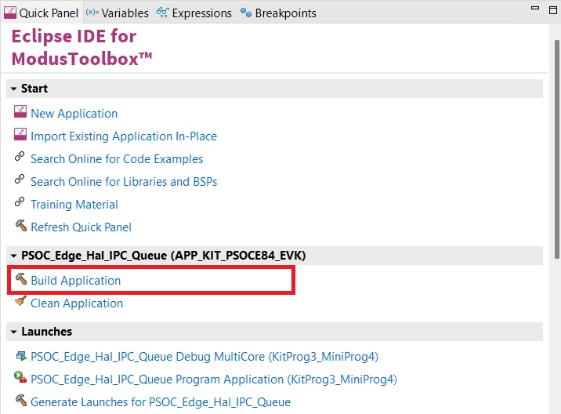
- After the Build process is successfully completed. We can program the board by clicking the Launch button in the Quick Panel.
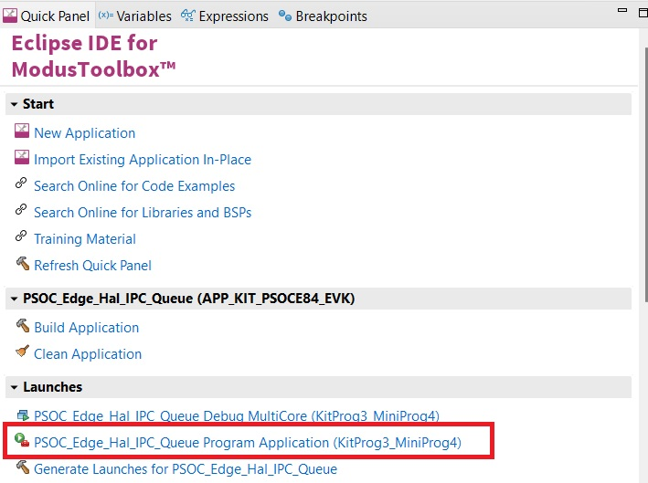
- After programing is successful, Connect the board to your PC using the provided USB cable through the KitProg3 USB connector.
- Open a terminal program and select the KitProg3 COM port. Set the serial port parameters to 8N1 and 115200 baud.
- You will see the message as shown in below image. Pressing the User Button once will Start the random number generation and pressing it again will Stop the random number generation.
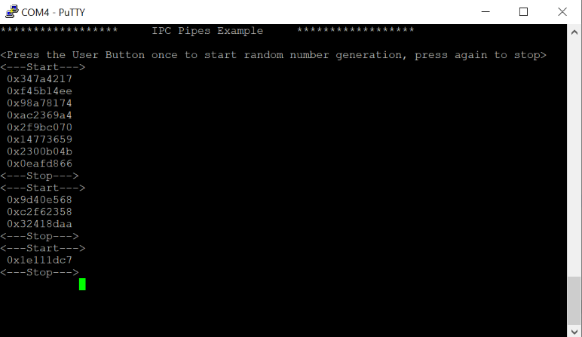
  - Conclusion
We successfully created PSOC™ Edge E84 IPC HAL Queue application using Modus Tool Box, figured out to use IPC HAL Libraries and communication between two cores using IPC queues.

References
- AN235935: Getting started with PSOC™ Edge E84 MCU on ModusToolbox™
https://doc.cypress.com/dms3/details?&docNum=002-35935&searchresultsurl=test

